**Script for Male Examination**

**[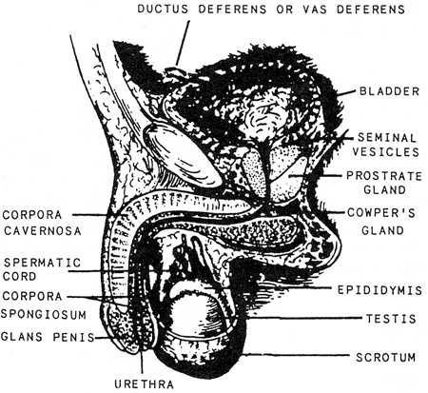](http://www.brooksidepress.org/Products/OperationalMedicine/DATA/operationalmed/Manuals/HM32/Chapter03/fig03-55.gif)**Ask about frequency of urination, including urgency, hesitation, pain, blood, absence or diminishing amount of urine, pus, color, and dribbling or incontinence; and check for past or present evidence of sexually transmitted diseases (STD). Also ask about possible exposure to STD’s.

**Scrotum**

The scrotum is a cutaneous pouch containing the testes and part of the spermatic cord. Immediately beneath the skin is a thin layer of muscular fibers (cremaster), which is controlled by temperature and contracts or relaxes to lower or raise the testes in relation to the body. This muscular activity of the scrotum is necessary to regulate the temperature of the testes, which is important in the maturation of sperm cells.

Male Anatomy

* The left testicle / scrotum usually hangs lower. Sebaceous cysts are a common lump found on the skin.

[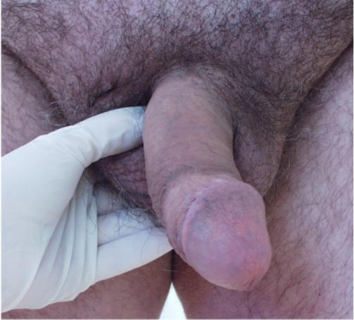](http://www.brooksidepress.org/Products/OperationalMedicine/DATA/operationalmed/Exams/TesticleCheck.jpg)**Testes**

The testes are oval glands suspended by the spermatic cord in a pouch. They perform two functions: production of spermatozoa (sperm) and secretion of the male sex hormone testosterone.

* Check by palpating using the thumb and first two fingers.
* They should feel smooth, rubbery, but free of nodules. Irregularities in texture or size may indicate cyst or tumor.

Lying close to the superior pole of each testis is the epididymus, a ductal system that collects and transmits sperm from the testes.

Palpate each testicle for enlargement, irregularity or tenderness.

* Should be smooth, discrete, and non-tender.

**Spermatic Cords**

[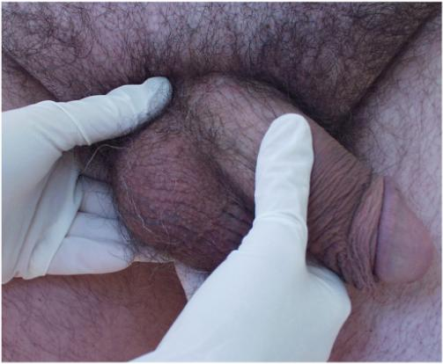](http://www.brooksidepress.org/Products/OperationalMedicine/DATA/operationalmed/Exams/SpermaticCord%20Check.jpg)The two spermatic cords, each of which suspends and supplies a testis, are formed by the ductus deferens, arteries, veins, lymphatics, and nerves, bound together by connective tissue.

* Palpate it between thumb and forefinger. It should not be tender, although stretching of the tissues will cause discomfort.
* Note any swelling or nodules
* A varicocele, if present, will be felt in this area.

Feel the spermatic cord as it rises from the testicle into the abdomen.

**Penis**

[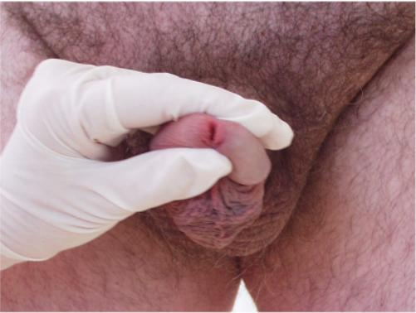](http://www.brooksidepress.org/Products/OperationalMedicine/DATA/operationalmed/Exams/UrethralDischarge.jpg)The penis is composed of three cylindrical bodies of spongy cavernous tissue, bound together by connective tissue and loosely covered by a layer of skin. Two of the bodies, the corpora cavernosa, lie superiorly side by side; the third body, the corpus spongiosum, is median, lying in the groove between the other two. The dilated distal end of the corpus spongiosum is known as the glans penis. The cavernous tissue becomes greatly distended with blood during sexual excitement, causing erection of the penis. The loose skin of the penis folds back on itself at the distal end, forming the prepuce, or foreskin, and covers the glans. Frequently, the prepuce is surgically removed (circumcision).

* Note if circumcised, if not is the foreskin easy to retract, check the external meatus of the urethra, note any discharge. Palpate the shaft for tenderness or lesions.
* Look for any ulcers, nodules, or evidence of inflammation

Check for urethral discharge by compressing the meatus between thumb and forefinger.

* Check the pubic hair at the base of the penis for nits or lice.
* If the patient reports a urethral discharge, but you don't see anything, strip the urethra, by compressing it at the base of the penis and milking any secretions up to the glans.
* Any discharge should ideally be cultured and gram stained.

**Prostate Gland**

[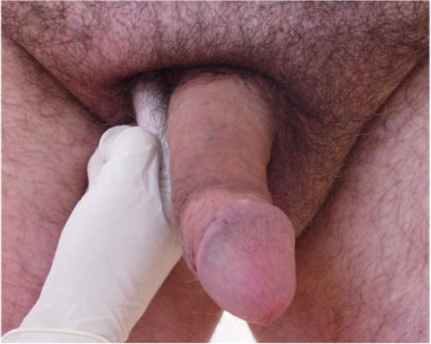](http://www.brooksidepress.org/Products/OperationalMedicine/DATA/operationalmed/Exams/HerniaCheck.jpg)The prostate gland is made of smooth muscle and glandular tissue that surrounds the first part of the urethra. It resembles a chestnut in shape and size. It secretes an alkaline fluid to keep the sperm mobile and protect it from the acid secretions of the female vagina. This substance is discharged into the urethra as part of the ejaculate, or semen, during the sexual act.

**Check for hernia:**

* With the patient standing inspect the area of the inguinal canal while he bears down or strains as if having a bowel movement.

Using an index finger, probe the inguinal ring. Have the patient cough, and feel for pulsation and descent of intra-abdominal contents through the ring and onto the tip of your finger

* After inspecting, insert a finger into the lower scrotum.
* Ask patient to cough.
* If a hernia is present, you should feel intestine push against your finger.